 v

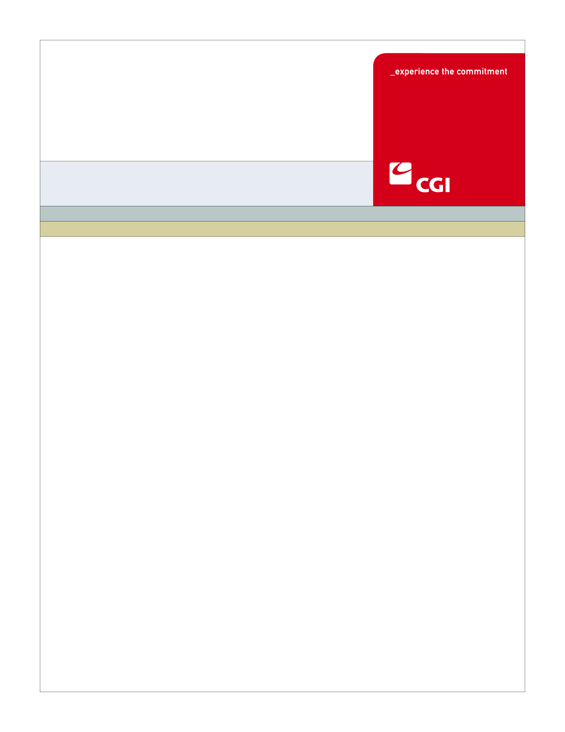

**Version 10.0**

**May 7, 2013**

**D-43 Carrier Test Plan**

1. Table of Contents

1 Overview 1

2 Test Phases 1

2.1 Basic Connectivity 1

2.2 Simple Web Service 2

2.3 Simple Web Service with Security 2

2.4 Basic Group Web Services 3

2.5 Basic Enrollment Web Services 3

2.6 Basic Payment Web Services 4

2.7 Functional Confirmation – Group 4

2.8 Functional Confirmation – Enrollment 5

2.9 Functional Confirmation – Payment 5

2.10 SFTP File Transfer Process 6

3 Technical Sessions 6

4 Documentation 7

5 Verification 7

**Revision History**

|  |  |  |  |
| --- | --- | --- | --- |
| Version | Date | Modified By | Description |
| 1.0 | 05/07/2013 | David Jurk | Initial version |
|  |  |  |  |

# Overview

Carrier interoperability testing involves a ten-step sequence of gradually progressive demonstrations of web service capability and functionality for the business services described in the following documents:

* *Carrier Enrollment Interface Control Document*
* *Carrier Enrollment ICD Companion Guide*
* *Carrier Payment Interface Control Document*
* *Carrier Payment ICD Companion Guide*

These services consist of a number of web services that are both consumed and hosted by Carriers and HBE, intended to provide efficient and secure messaging that is both flexible and performant.

Each testing phase will consist of the following elements:

1. Documentation that provides necessary details and technical specification needed to construct and call web services covered by that phase.
2. A technical session between Carriers’ IT resources and HBE in which standards are discussed and agreed upon, questions raised and answered, and documentation reviewed.
3. A specific test script, or scripts, that specifies the exact steps involved in the testing, noting all details necessary for its execution.
4. A results log registering test script results, produced by both Carriers and HBE that documents the results of the testing.

# Test Phases

The following sections describe the ten Test Phases.

## Basic Connectivity

**Goal:** To assure visibility across the network from both Carrier and VT HBE consumer (or client) perspectives.

**Start:** 1 May 2013

**Finish:** 17 May 2013

**Prerequisites:** None

**Preparation:** Either Ping or Telnet inbound and outbound capability

**Steps:**

1. Carrier pings or telnets HBE development server
2. HBE pings or telnets Carrier development server

**Outcome:** Confirmation of successful connectivity

## Simple Web Service

**Goal:** To implement a simple web service, hosted by both Carrier and HBE, to confirm web service provider/consumer model.

**Start:** 20 May 2013

**Finish:** 31 May 2013

**Prerequisites:** Test service description

**Preparation:** Web service hosting and consuming client capability (client can be a utility such as SoapUI)

**Steps:**

1. Carrier calls “Test Service” on HBE development server, request message is echoed back synchronously.
2. HBE calls “Test Service” on Carrier development server, request message is echoed back synchronously.

**Outcome:** Confirmation that both web services responded with appropriate messages

## Simple Web Service with Security

**Goal:** To layer WS-Security 1.1 onto “Test Service”

**Start:** 3 June 2013

**Finish:** 14 June 2013

**Prerequisites:** Simple Web Service, self-signed x.509 certificate, public/private key pair

**Preparation:** Establish key exchange process, Exchange public keys

**Steps:**

1. Carrier calls “Test Service” on HBE development server with full WS-Security 1.1, request message is echoed back synchronously
2. HBE calls “Test Service” on Carrier development server with full WS-Security 1.1, request message is echoed back synchronously

**Outcome:** Confirmation of successful security handshaking, both web services respond with appropriate messages

## Basic Group Web Services

**Goal:** To implement the basic Group web service interfaces (no functionality)

**Start:** 3 June 2103

**Finish:** 14 June 2013

**Prerequisites:** XSD layouts for “GA1” and “GA2” messages, interface test data

**Preparation:** Load client with call data, host with response data

**Steps:**

1. Carrier calls “Group” web service on HBE development server with “GA1” message, TA1 is synchronously returned
2. Carrier calls “Group Callback” web service on HBE development server with “GA2” message, TA1 is synchronously returned
3. HBE calls “Group” web service on Carrier development server with “GA1” message, TA1 is synchronously returned
4. HBE calls “Group Callback” web service on HBE development server with “GA2” message, TA1 is synchronously returned

**Outcome:** Confirmation of basic request/response interface for Group web services

## Basic Enrollment Web Services

**Goal:** To implement the basic Enrollment web service interfaces (no functionality)

**Start:** 17 June 2013

**Finish:** 28 June 2013

**Prerequisites:** XSD layouts for “834”, “999”, “enrollErr” messages, interface test data

**Preparation:** Load client with call data, host with response data

**Steps:**

1. HBE calls “Enroll” web service on Carrier development server with “834” message, TA1 is synchronously returned
2. Carrier calls “Enroll Callback” web service on HBE development server with “834” message (effectuated type, confirm type), TA1 is synchronously returned
3. Carrier calls “Enroll Callback” web service on HBE development server with “999” message, TA1 is synchronously returned
4. Carrier calls “Enroll Callback” web service on HBE development server with “enrollERR” message, TA1 is synchronously returned
5. Carrier calls “Enroll” web service on HBE development server with “834” message, TA1 is synchronously returned
6. HBE calls “Enroll Callback” web service on Carrier development server with “834” message (834Conf type), TA1 is synchronously returned.
7. HBE calls “Enroll Callback” web service on Carrier development server with “enrollErr” message, TA1 is synchronously returned

**Outcome:** Confirmation of basic request/response interface for Enrollment web services

## Basic Payment Web Services

**Goal:** To implement the basic Payment web service interfaces (no functionality)

**Start:** 1 July 2013

**Finish:** 12 July 2013

**Prerequisites:** XSD layouts for “820”, “820PAY” and “validationERR” messages, interface test data

**Preparation:** Load client with call data, host with response data

**Steps:**

1. HBE calls “Payment” web service on Carrier development server with “820PAY” message, TA1 is synchronously returned
2. HBE calls “Remittance” web service on Carrier development server with “820” message, TA1 is synchronously returned.
3. Carrier calls “Remittance Callback” web service on Carrier development server with “validationErr” message, TA1 is synchronously returned

**Outcome:** Confirmation of basic request/response interface for Payment web services

## Functional Confirmation – Group

**Goal:** To validate usage scenario data flow via Group web services

**Start:** 15 July 2013

**Finish:** 19 July 2013

**Prerequisites:** Usage scenarios, test data, business logic integration

**Preparation:** Load client with test call data

**Steps:**

1. Carrier calls “Group” web service on HBE development server with “GA1” message for termination usage scenario, TA1 is synchronously returned
2. HBE calls “Group Callback” web service on Carrier development server with appropriate “GA2” response message based on internal HBE business logic, TA1 is synchronously returned
3. HBE calls “Group” web service on Carrier development server with “GA1” message for all usage scenarios, TA1 is synchronously returned
4. Carrier calls “Group Callback” web service on HBE development server with “GA2” response message based on Carrier internal business logic, TA1 is synchronously returned

**Outcome:** Confirmation of appropriate and expected business logic responses to all Group usage scenarios

## Functional Confirmation – Enrollment

**Goal:** To validate usage scenario data flow via Enrollment web services

**Start:** 22 July 2013

**Finish:** 9 August 2013

**Prerequisites:** Usage scenarios, test data, business logic integration

**Preparation:** Load client with test call data

**Steps:**

1. HBE calls “Enroll” web service on Carrier development server with “834” message for all enrollment usage scenarios, TA1 is synchronously returned
2. Carrier calls “Enroll Callback” web service on HBE development server with appropriate response message based on business logic, TA1 is synchronously returned
3. Carrier calls “Enroll” web service on HBE development server with “834” message for termination usage scenarios, TA1 is synchronously returned
4. HBE calls “Enroll Callback” web service on Carrier development server with appropriate message based on business logic, TA1 is synchronously returned

**Outcome:** Confirmation of appropriate and expected business logic responses to all Enrollment usage scenarios

## Functional Confirmation – Payment

**Goal:** To validate usage scenario data flow via Payment web services

**Start:** 12 August 2013

**Finish:** 23 August 2013

**Prerequisites:** Usage scenarios, test data, business logic integration

**Preparation:** Load client with test call data

**Steps:**

1. HBE calls “Payment” web service on Carrier development server with “820PAY” message for all payment usage scenarios, TA1 is synchronously returned
2. HBE calls “Remittance” web service on Carrier development server with “820” message for all remittance usage scenarios, TA1 is synchronously returned.
3. Carrier calls “Remittance Callback” web service on Carrier development server with appropriate message based on business logic, TA1 is synchronously returned

**Outcome:** Confirmation of appropriate and expected business logic responses to all Payment usage scenarios

## SFTP File Transfer Process

**Goal:** To implement the SFTP secure file transfer process

**Start:** 26 August 2013

**Finish:** 30 August 2013

**Prerequisites:** FTP Server Infrastructures and accounts, security mechanisms, secure email mechanisms, usage scenarios

**Preparation:** Test files

**Steps:**

1. HBE initiates secure file transfer process to Carrier via email
2. HBE transfers file under all usage scenarios to Carrier
3. Carrier responds appropriately according to business rules and transfer protocol

**Outcome:** Validation of secure file transfer process and protocols

# Technical Sessions

For testing phases 2 through 10, technical sessions will be scheduled between Carrier IT staff and HBE resources. These sessions (one per test phase) are intended to:

* Review test goals, procedures, documentation, and deliverables for that phase
* Walk through the test script
* Review test data, security, and business logic as appropriate
* Establish ongoing standards and mutual practices
* Answer questions related to technology, infrastructure, processes, and technical design

The schedule for these sessions is:

1. Basic Connectivity – None
2. Simple Web Service – Week of 13 May 2013
3. Simple Web Service with Security – Week of 27 May 2013
4. Basic Group Web Services – Week of 10 June 2013
5. Basic Enrollment Web Services – Week of 10 June 2013
6. Basic Payment Web Services – Week of 24 June 2013
7. Group Functional – Week of 8 July 2013
8. Enrollment Functional – Week of 15 July 2013
9. Payment Functional – Week of 5 August 2013
10. SFTP - Week of 19 August 2013

# Documentation

Both the technical sessions that serve as a precursor to the testing, as well as the testing itself, requires several forms of documentation. These documents will be provided as much in advance of the actual testing as possible, with delivery no later than the beginning of the technical sessions.

The documentation will consist of:

* Standards and process proposals, where these are needed
* Test data, both request and response
* XSD and WSDL layouts, as appropriate
* Test scripts with expected results where appropriate
* Usage scenarios, where appropriate

# Verification

All tests should be comprehensively logged, so that both Carrier and HBE have complete documentation covering the test performance. These may include, but not be limited to:

* System logs
* Screen shots of middleware or test client request/response data
* Signed-off test scripts, verifying test case status